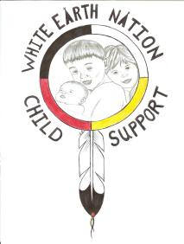

White Earth Nation Child Support
IV-D Program (WEN CSP)
P.O. Box 387 • White Earth, MN 56591 • Tel. (218) 935-3512
Fax (833) •859-0834

VERIFICATION CHECKLIST

We will need the following verification and documentation in order to proceed with the processing of your application for Child Support Services:

- Verification of your Social Security Number (for example, a copy of your Social Security card, pay stub)

- Verification of your child(ren)’s Social Security Number

- Birth Certificate for your child(ren) - (actual or copy of the birth certificate)

- Verification of your address (rent receipt, utility bill, mail received by you at that address)

- Copies of any court orders (Divorce/Dissolution, Temporary Support, child support, etc.) that have already been issued

- If Family Violence is claimed, then we will need a copy of the police report, Restraining Order or Order of Protection issued by a court, or statement from two individuals attesting to the family violence.

- Copies of any receipts, records or proof of child support that has already been paid to you

- Tribal Membership

