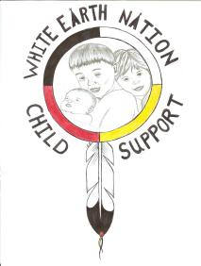

White Earth Nation Child Support
IV-D Program (WEN CSP)
P.O. Box 387 • White Earth, MN 56591 • Tel. (218) 935-3512
Fax (833) •859-0834 •

Change of Address Form

Please indicate if you are the custodial or non-custodial parent below:

- Custodial Parent
- Non-custodial Parent

Case Number(s): _______________________________________
___________________________________________________

Current Address: Previous Address:

Name: __________________________ Address: ___________________
Address: ________________________ ___________________________
________________________________ ___________________________
________________________________ ___________________________
Phone: __________________________
Alt Phone: _______________________
Email:___________________________

White Earth Nation Child Support Office would like to remind all clients the importance of updating your address and telephone numbers with our office.

At any given time, we could possibly need to contact our clients regarding payments, court dates, updates, or concerns with your child support case.

If you have any questions/concerns please contact our office Monday through Friday 8:00 AM- 4:30PM by calling 218-935-3512 or stopping in the office at the RBC Headquarters located at: 35500 Eagle View Rd, Ogema, MN 56569.

