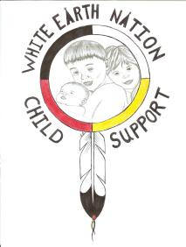

White Earth Nation Child Support
IV-D Program (WEN CSP)
P.O. Box 387 • White Earth, MN 56591 • Tel. (218) 935-3512
Fax 833-859-0834

Payment History Request

I, _______________________, am requesting a financial statement of all child support payments made for the last ______months.

Case Number(s): ________________________________________________

Custodial Parent Information: Non-Custodial Parent:

Name: ______________________ Name: ___________________________
Address: ____________________ Address: _________________________
____________________________ _________________________________
____________________________ _________________________________
Phone: ______________________ Phone: ___________________________

Child(ren):
Name: ______________________ DOB: ________________________
Name: ______________________ DOB: ________________________
Name: ______________________ DOB: ________________________
Name: ______________________ DOB: ________________________
Name: ______________________ DOB: ________________________

Please describe the reason/reasons you would like to have a financial statement sent to you:
_____________________________________________________________________________________________________________________________________________________________________________________________________________________________________________

Please note: White Earth Nation has up to 3 business days to provide a statement. Payment History Requests are processed in the order received.

Signed: _____________________ Dated: ____________________
Print: Name: _________________

