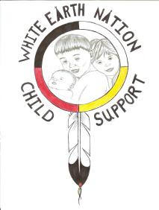

White Earth Nation Child Support
IV-D Program (WEN CSP)
P.O. Box 387 • White Earth, MN 56591 • Tel. (218) 935-3512
Fax 833-859-0834

RELEASE OF INFORMATION

READ FIRST: Before you decide whether to let White Earth Nation Child Support share case information with another agency or person, an advocate at White Earth Nation Child Support will discuss with you all alternatives and any potential risks and benefits that could result from sharing your case information.

I hereby authorize the White Earth Nation Child Support Program to release information about my Child Support case to the following person/agency:

Name:______________________ Relationship:____________________
Name:______________________ Relationship:____________________
Name:______________________ Relationship:____________________
Name:______________________ Relationship:____________________

Other:__________________________________________________________

I Understand:
- That I do not have to sign a release form. I do not have to allow White Earth Nation Child Support to share my information except for the agency to perform their duties. Signing a release form is completely voluntary. That this release is limited to whom I write in above.

- That releasing information about me could give another agency information about my location and would confirm that I have been receiving services from White Earth Nation Child Support.

- That White Earth Nation Child Support and I may not be able to control what happens to my information once it has been released to the above person/agency, and that the agency or person getting my information may be required by law or practice to share it with others.

I understand that this release is valid when I sign it and that I may withdraw my consent to this release at any time either orally or in writing.

Print Name: _______________________ Signed: _____________________________
(custodial parent/non-custodial parent)

Case Number: ______________________ Date: ________________

Witness: __________________________

